**KIONGE HIGH VIEW SECONDARY SCHOOL**

**END OF TERM 1 CHEMISTRY**

**SENIOR TWO**

**2HOURS;10 MINUTES**

ATTEMPT ALL QUESTIONS

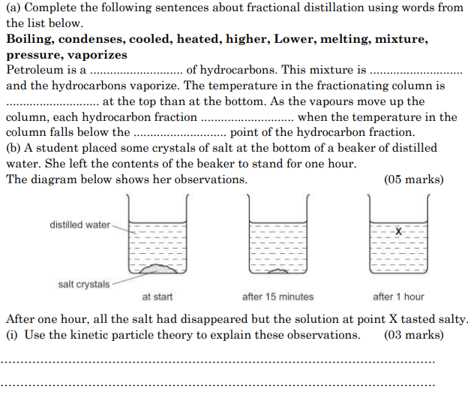

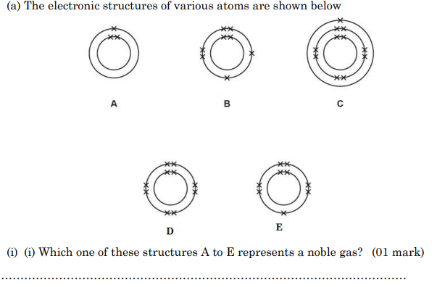

1. Identify the name of the elements
2. …………………………………
3. ..………………………………
4. ….………………………………….
5. ….……………………………………
6. ….……………………………………

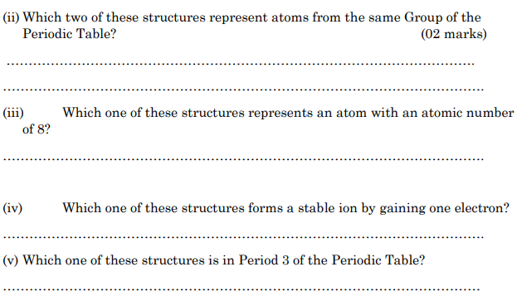

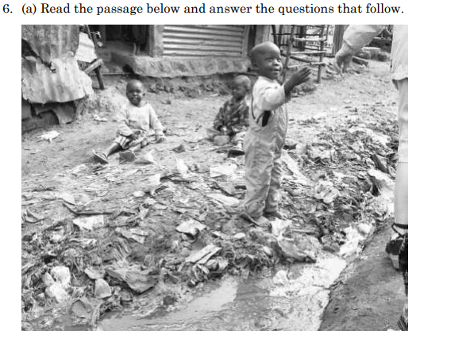

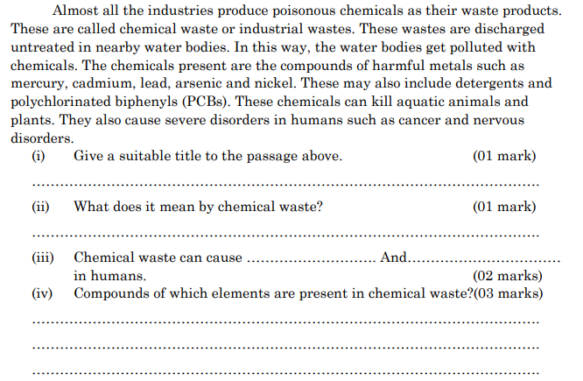

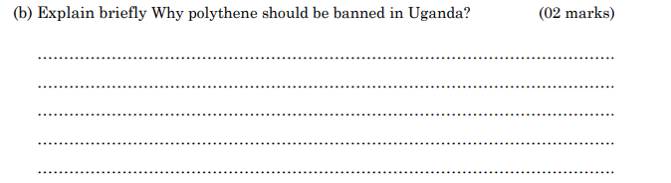

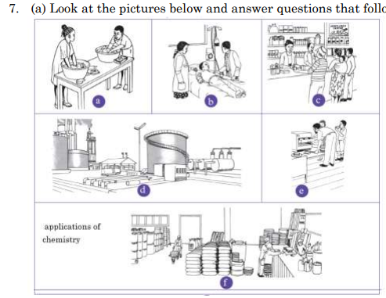

1. How are the events in the pictures relevant in our lives? (04 marks)

….………………………………………………………………………………………………………………………………………………………………………………………………………………………………………………………………………………………………………………………………………………………………………………………………………………………………………………………………………………………………………………………………………………………………………………………………………………………………………………………

1. What would happen if the events in the pictures didn’t happen? (03marks)

….…………………………………………………………………………………………………………………………………………………………………………………………………………………………………………………………………………………………………………………………………………………………………………………………………………………………………………………………………………………………………………………………………………………………………………………………………………………………………………………………

1. Write short notes on the importance of Chemistry in our lives. (03marks)

_________________________________________________________________________________________________________________________________________________________________________________________________________________________________________________________